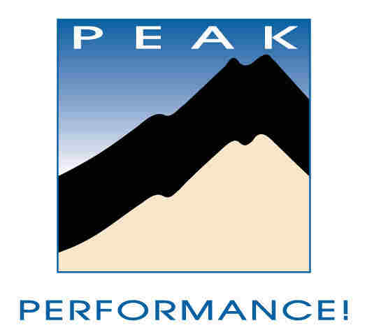

FIVE MINUTE LEADERSHIP WORKSHOP™
An Investment in Higher Achievement

METRICS MATTER:
WHAT GETS MEASURED GETS IMPROVED

PREPAREDNESS
- Prepare and take action to be uninterrupted for at least five minutes
- Close your eyes. Pause. Take three, deep, slow breathes, while you clear your mind of everything else. (Really…it makes a difference!)
- Ask yourself: “What’s in it for me? (WIFM), if I improve my leadership?” List three answers.

ACTIVITY
Read the following slowly, really thinking about what it could mean to you. It’s less important that you agree, than that you understand and explore the concept FULLY.
We were leading a three-day leadership retreat for an organization involved in environmental stewardship issues who listed “reducing waste” as one of their important values. Without announcing our plans or why we were doing it, we weighed and totaled the food waste put by participants into the dining room refuse containers after each meal. We posted the total weight on the bulletin board with only a caption explaining what had been weighed. By the third meal, the participants had cut in half the amount of food waste—without anyone asking them to. And the number kept dropping.
What gets measured and shared gets improved. Whether you mean to or not.
Many organizations spend enormous resources measuring things that don’t help them, and still miss the crucial metrics. Others quantify important metrics, yet the people who need the data don’t get it. In Ken Blanchard’s famous “One Minute Manager,” he paints a powerful mental picture: Imagine a game of bowling where every time you released the ball, a curtain came down in front of you, obscuring the results of your throw.
How can your team improve unless they know how they’re doing? This doesn’t mean appointing a committee and waiting six months for an in-depth report. It means immediate, quantitative, constructive feedback. In our programs, we teach quick and efficient ways to “check in,” acquire data, and use it to immediately improve performance.
Metrics matter. Ask the right questions, share the answers, and don’t waste resources on information that doesn’t improve performance.
REFLECTION
What is my initial, knee-jerk reaction to this concept?
Am I measuring the right things? Does everyone know how they and the team are doing?
Is the drive to improve numbers extrinsic and “top down,” or driven by a close correlation between the metrics and values?
SELF-ASSESSMENT
How do I choose what to measure and report to the team? Are they related to my values—is what I say important?
Who has input into what metrics I use to measure and improve my and my team’s success?
ACTION PLAN
Identify one action I can take today (preferably right now!) to move toward measuring “the right stuff.”

List two things I can do this week to bring the power of ACTION to the words and concept!

Who else might I enlist to help me?

Who can I tell about my action plan, to help insure accountability?

For a free, no-obligation assessment of your teams strengths & vulnerabilities AND a free report with recommendations for improvement, email: info@peaktraining.com, or visit http://www.peaktraining.com/corp/Corporate-Retreats.html

The Five Minute Leadership Workshop™ is a free service of Peak Performance!™. We encourage you to share this with your colleagues and teams, as long as you leave intact and include the identifying and attribution information below.
I hear and I forget...I see and I remember...I do and I understand.

© Peak Performance Training Systems, Inc., rights reserved.
1.888.875.7325 (PEAK)
phone: 719.276.2125 ▪ fax: 719.276.2103 ▪ e-mail: info@peaktraining.com ▪ http://www.peaktraining.com/corp/Leadership-Training.html

