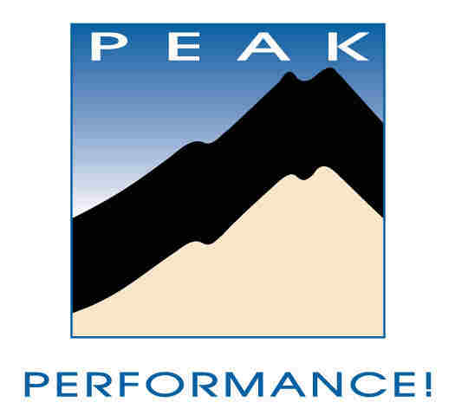
FIVE MINUTE LEADERSHIP WORKSHOP™
An investment in Higher Achievement

PREPAREDNESS
- Prepare and take action to be uninterrupted for just five minutes
- Close your eyes. Pause. Take three, deep, slow breathes, while you clear your mind of everything else. (Really…it makes a difference!)
- Ask yourself: “What’s in it for me? (WIFM), if I improve my leadership?” List three answers.

ACTIVITY
Read the following slowly, really thinking about what it could mean to you. It’s less important that you agree, than that you understand and explore the concept FULLY.

When times get tough (and they invariably do, eventually!) we may need to do more with less, identify our most valuable resources and make them do “double-duty” to they providing additional return-on-asset. (The 80/20 rule suggests that 80% of value comes from 20% of assets!) William H. Danforth, founder of Ralston-Purina, had a unique “test” to determine the relative value of resources:
“Our most valuable possessions are those that can be shared without lessening; those which, when shared, multiply. Our least valuable possessions are those which when divided are diminished.
“The more you pour out, the more you have to pour. The more of life’s treasures you keep to yourself, the less you have. The more you share with others, the more you have yourself. The more you give, the more you get.”
Investing some of the key components of leadership in those with whom you work isn’t a “zero-sum” game. You literally create more assets “out of thin air"! Instead of leaving you with less, they are reflected back; so that, not only does the group have resources that didn’t previously exist, YOU actually have more of that resource as well.

REFLECTION
What is my initial, knee-jerk reaction to this concept?

Now, dig deeper. List as many examples as I can in each “category” of assets -- those diminished or multiplied by sharing.

What happens to a team when I share with them?

Where do these fit: Vision? Hope? Excitement? Knowledge? Skill? Connectedness? What others?

SELF-ASSESSMENT
Honestly, what is my practice and habit in using this concept with those I interact with?

How do those around me rate in understanding and using this concept?

ACTION PLAN
Identify one action I can take today (preferably right now!) to move toward implementation.

List at least two (realistic and ACHIEVABLE) things I can do this week to bring the power of ACTION to the words and concept!

Who else might I enlist to help me?

Who can I tell about my action plan to help insure accountability?

NOTES: (follow-up, forward to, related concepts, etc.)

For a free, no-obligation assessment of your team's strengths & vulnerabilities AND a free report with recommendations for improvement, email: info@peaktraining.com, or visit www.peaktraining.com/corp/Corporate-List-Of-Services.html

The Five Minute Leadership Workshop™ is a free service of Peak Performance!™. We encourage you to share this with your colleagues and teams, as long as you leave intact and include the identifying and attribution information below.

I hear and I forget...I see and I remember...I do and I understand.

Peak Performance Training Systems, Inc.
1.888.875.7325 (PEAK)
phone: 719.276.2125 ▪ fax: 719.276.2103 ▪ e-mail: info@peaktraining.com ▪ www.peaktraining.com

Danforth, William H. “I Dare You”, p. 20, American Youth Foundation, St. Louis, MO, ISBN: 0-9602416

